**Day 2 Activities: Transitioning to Technical Planning**

1. **Technical Requirement:**

* **Frontend Requirements:**

The frontend is designed to deliver a seamless, user-friendly experience across all devices. Key requirements include:

* + User-friendly environment to browse data:
  + Responsive webpage
  + pages are

(Home , login , signup , contact , cart , billing , products) etc.

* **Sanity CMS as Backend:**

Sanity CMS is used as the backend system to manage and store the platform's data. Key requirements include:

**Data Management:**

* + Products: Manage product details like name, price, description, and stock availability.
  + Customers: Store customer profiles and contact information.
  + Orders: Maintain order records, including order status and payment details.

**Schema Design:**

* + Define schemas in Sanity CMS to align with the business objectives identified on Day 1.
  + Ensure the schemas efficiently support the marketplace's scalability and functionality.
* **Third-Party API Integrations**

To enhance functionality and provide essential services, integrate the following APIs:

* + **Shipment Tracking API:** Fetch and display real-time shipment updates for customers.
  + **Payment Gateway API:** Facilitate secure payment processing during the checkout process.
  + **Additional Backend Services:** Integrate other APIs as necessary to support features like tax calculation, discounts, or analytics.
  + **Data Flow:** Ensure the APIs provide accurate and relevant data for frontend interactions, including updates for order status, payment confirmations, and tracking information.

1. **Designing the System Architecture:**

* **System Architecture Overview**

The system architecture consists of the following core components:

* **Frontend (Next.js):** Handles user interactions and displays dynamic content.
* **Sanity CMS:** Acts as the backend, managing product data, customer profiles, and order details.
* **Third-Party APIs:** Supports functionalities like shipment tracking and payment processing.
* **Payment Gateway:** Secures payment processing and ensures successful transactions.

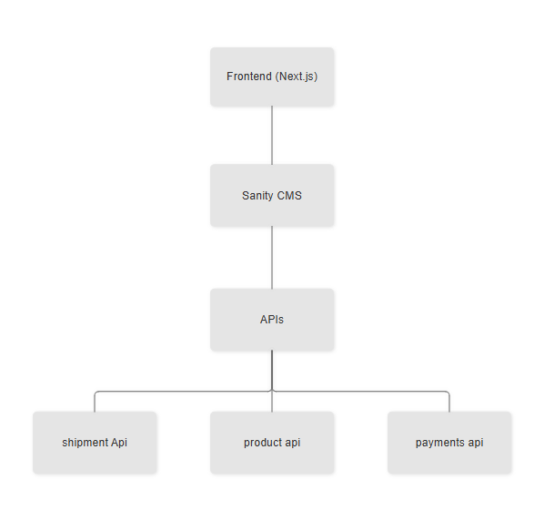

* User Registration:

User signs up -> Data is stored in Sanity -> Confirmation sent to the user.

* Product Browsing:

User views product categories -> Sanity API fetches data -> Products displayed on frontend.

* Order Placement:

User adds items to the cart -> Proceeds to checkout -> Order details saved in Sanity.

* Shipment Tracking:

Order status updates fetched via 3rd-party API -> Displayed to the user.

1. **Planning API Requirements:**

|  |  |  |  |  |
| --- | --- | --- | --- | --- |
| Endpoint Name | Method | Description | Request Payload | Response Example |
| /products | GET | Fetch all the available products from Sanity. | None | { "id": 1, "name": "Product A", "price": 100, "stock": 20, "image": "product-a.jpg" } |
| /orders | POST | |  | | --- | |  |  |  | | --- | | Create a new order in Sanity. | | { "customerId": 123, "products": [{ "productId": 1, "quantity": 2 }], "paymentStatus": "Paid" } | { "orderId": 456, "status": "Success", "message": "Order created successfully." } |
| /shipment | GET | |  | | --- | |  |  |  | | --- | | Track order status via a third-party API. | | None | { "shipmentId": 789, "orderId": 456, "status": "In Transit", "expectedDelivery": "2025-01-20" } |

1. **Sanity Schema Example:**

|  |
| --- |
| {  "success": true,  "data": [  {  "productName": "Nike Air Force 1 Mid '07",  "category": "Men's Shoes",  "price": 10795,  "inventory": 20,  "colors": [  "White"  ],  "status": "Just In",  "image": "https://template-03-api.vercel.app/products/1.png",  "description": "The Nike Air Force 1 Mid '07 delivers timeless style with premium leather and mid-cut design. Perfect for everyday wear, it provides exceptional comfort and durability. The iconic Air-Sole cushioning adds responsive support for long-lasting performance."  },  ]  } |